OVERVIEW
SIP2teams is a cloud SBC service that provides SIP Trunk call integration to a Microsoft Teams tenant with a managed Microsoft phone system via Microsoft Direct Routing.
The SIP Trunk is provided as an addition to SIP2teams integration allowing your provider to build a solution that perfectly fits your business requirements. SIP2teams provides a better value, enhanced and manageable alternative to ‘Microsoft Teams Calling Plans’, which can be expensive and provide little additional features.

What is Microsoft Direct Routing?
Direct Routing is a Microsoft Teams feature that lets you connect a supported Session Border Controller (SBC) to a Microsoft Phone System.
With this capability, for example, a local geographic non-Microsoft telephone calling option to work with a Microsoft Teams client.
The traffic connection between Microsoft and an SBC is typically over the internet and the VOIP call or PSTN break out is local to the SBC location.

WHY CHOOSE SIP2TEAMS?
SIP2teams offers an enhanced highly available and highly secure telephone number call alternative to the native Microsoft Teams Calling Plans using Direct Routing and all at a flexible and competitive price point.
SIP2teams is a cloud-based Session Border Controller (SBC) service residing ‘within’ Microsoft’s Azure Cluster and so does not pass traffic over the internet. SIP2teams offers a noted enhanced service, that registers to a partner chosen SIP Trunk along with associated telephone number ranges and configures them for use by a user phone system license or service, pre-provisioned in a Microsoft Teams tenant phone system.
The SIP2teams service offers a traditional phone system style ‘User to Line ratio’ opportunity, meaning the number of SIP channels does not have to match the User and Services count on the Teams tenant.
Flexible to fit your business needs
Highly Available, Highly Secure
For example, a typical 1:1 (Teams user: SIP Channel or MS Calling Plan) ratio can be replaced by SIP2teams to replicate the time honoured 1:3 (User: Line/Channel) ratio from traditional PBX solutions.
True unified collaboration and communication
Cost effective alternative to Microsoft Calling Plans
Furthermore, this ratio can be scaled to suit any potential end requirement e.g 1:4, 1:8, 1:20 etc…. depending on the required capacity for inbound or outbound calls by the company tenant at any one time.

KEY BENEFITS OF SIP2TEAMS
It’s simple, Telco providers provide a better calling service for their customers. They understand customers calling needs better than the IT giant, Microsoft.
- SIP2teams is secure within Microsoft’s Azure Cluster and is highly available.
- ‘AutoSync’ is a key feature that negates to need to carry out complicated ‘Powershell’ tasks to associate a telephone number to a Teams user or service. All essential and commonly missed task entries are fulfilled by this unique feature.
- No End User Microsoft 365 Admin credentials are held by the platform as they are not cached after token use.
When used with HV.Select SIP Trunking, Complimentary and compensatory features can be introduced to enhance or provide better control of inbound and outbound call establishment and experience, such as continuity plans, analytics, audio bridges, auto attendants to name a few.
Other key features and partner sales benefits include…
- No need to pre-pay for calls (which is the model used by Microsoft Calling Plans)
- Call anywhere, anytime, with great VoIP calling rates or bundled minutes.
- Flexible outbound number presentation
- Advanced call barring (HV.Select)
- Enhanced features: Inbound & Outbound Call Traffic Logging, Fax to email and Call Recording
- Fraud Prevention

TECHNICAL OVERVIEW
SIP2teams is hosted within Microsoft data centres so calls between SIP2teams and Office365 never leave the Microsoft infrastructure until PSTN breakout is required.
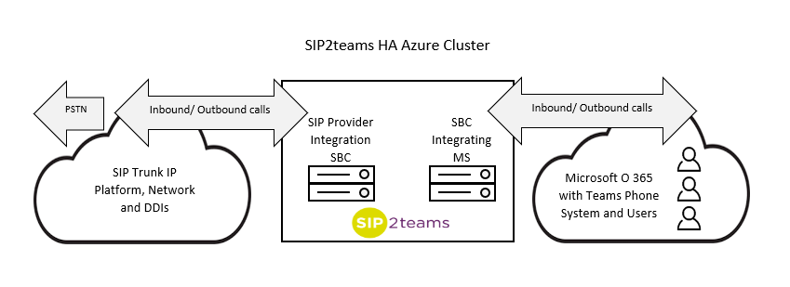
The intrastate is serviced via three High-Availability (HA) Azure clusters and the SIP2teams SBC network sits at the core of the solution connecting your SIP Trunk to Microsoft Teams.

Users connected to Office 365 place calls to the phone network and other Teams users via the Phone System user add in which is automatically integrated when used with SIP2teams to your SIP Trunk provider once credentials have been successfully set up.
SIP2teams performs end-to end encryption of signalling and media right up to the point of breakout over the chosen SIP trunk. A direct media path from SIP2teams SBCs and Teams clients provide media bypass, where Microsoft support this for region and tenant, and full MS-ICE is supported allowing the Teams client to negotiate the optimal media path.
Administration access to the SIP2teams portal is controlled via Azure/ Office65 ‘Single Sign on’. This means no user credentials are stored within the SIP2teams portal.

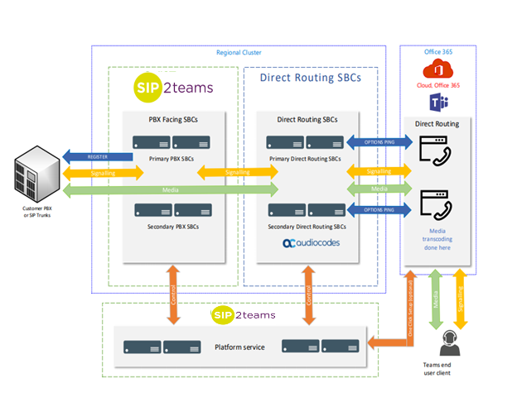
SIP2TEAMS NETWORK: KEY FACTS
- Operates across 4 continents
- Each customer has access to at least two nodes.
- Nodes are chosen automatically in the SIP2teams portal depending on location of customer phone service
- Operates in Primary/Secondary High-Availability Node architecture
- Separate SIP and Direct Routing SBC’S
- SIP SBCs manage SIP Trunk registration and call signalling
- Direct routing SBCs carry media between Microsoft and the Customer.
- The platform service spans the entire platform and manages all call routing and user access.
- Major nodes have multiple SBCs with ‘decomposed’ architecture, allowing elastic scalability.

End to End Security
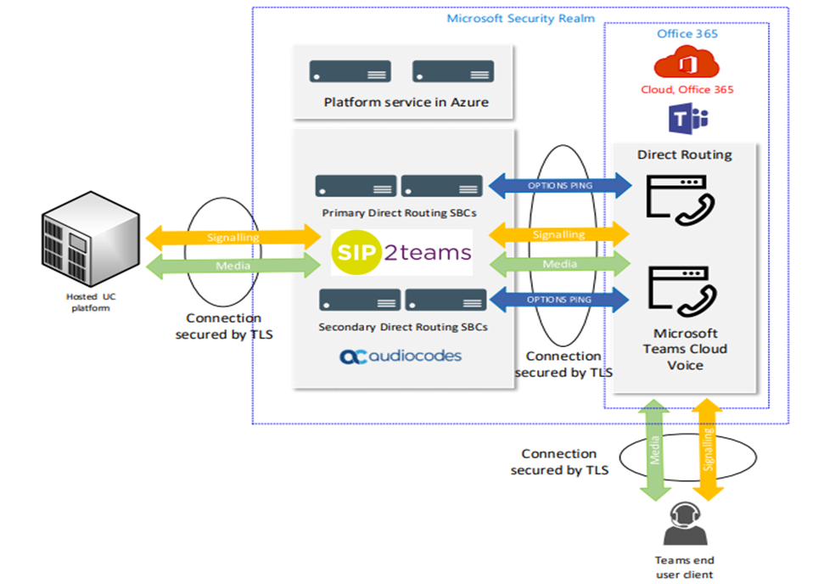
All call legs can be secured by TLS encryption (providing SIP service support this also).
TLS 1.2 or later is supported and the Platform infrastructure hosted ‘within’ Microsoft Azure. Your Customer data held in the Microsoft security realm for both Teams and SIP2Teams.

Latency & Call Quality
Teams users connect to the nearest Microsoft network Point of Presence (PoP) in the global network.
The global Microsoft network has extremely high-performance for Voice and carries the voice traffic for nearly the entire journey up to Public Switched Telephone Network (PSTN) breakout.
Documented Security
• ISO27001 and UK Gov Cyber Essentials certified organisation
• Comprehensive infosec documentation available (NDA)
• Minimal Personal Identifiable Data storage overheads
• Compliant with HIPPA business associate agreement

Through SIP2teams node optimisation, traffic will step-off the Microsoft network near to the Trunk so users do not report call quality or latency problems, even between continents
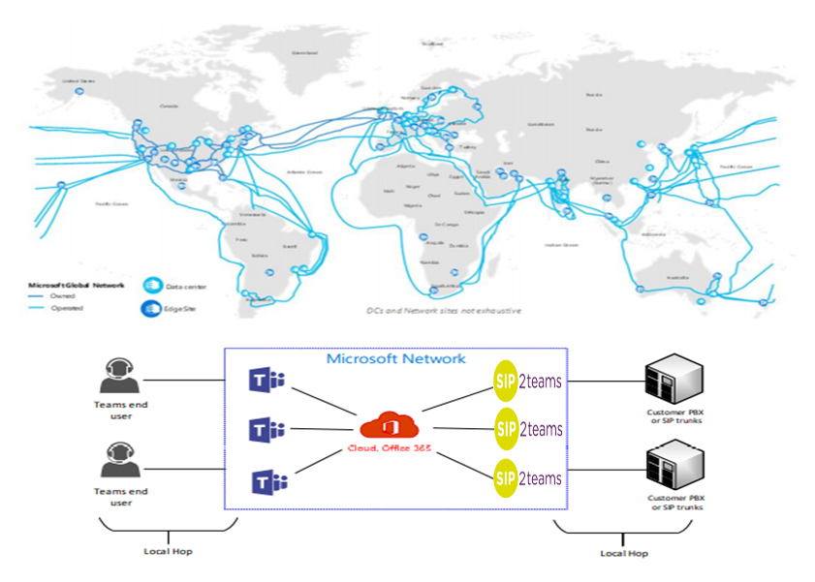

SLA Targets
• Microsoft Teams/PSTN Voice has an SLA target of 99.9%
• Azure components used by the platform have SLA targets of 99.9- 99.95%
• The architectural design uptime target of the SIP2teams platform is 99.99%
• Microsoft’s Teams SLA is the limiting underpinning factor
